Ex – 4 Code:

From nltk.stem import PorterStemmer

From nltk.tokenize import word_tokenize

Ps = PorterStemmer()

Sen = “In The Beginning , He was Running and Jumping”

Words = word_tokenize(sen)

For w in words:

Print(w,” : “,ps.stem(w))

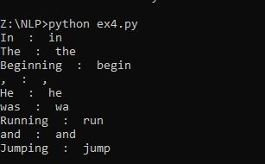

Ex – 5a code:

From nltk import ngrams

Def gen_ngrams(input,n):

Words = input.split()

Return[“ “.join(gram)for gram in ngrams(words,n)]

Input = “Hi How Are You”

N = 2

For ngram in gen_ngrams(input,n):

Print(ngram)

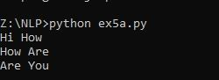

Ex-5b code:

From nltk import ngrams

Import nltk

Def gen_sengrams(input,n):

Return[“ “.join(gram)for gram in ngrams(input,n)]

Input = [“Never Gonna Give You Up.”,

“Never Gonna Let You Down.”,

“Never Gonna Run Around And Desert You.”,

“Rick Roll .”,

“Rick Astley.”

]

N = 2

For ngram in gen_sengrams(input,n):

Print(ngram)

